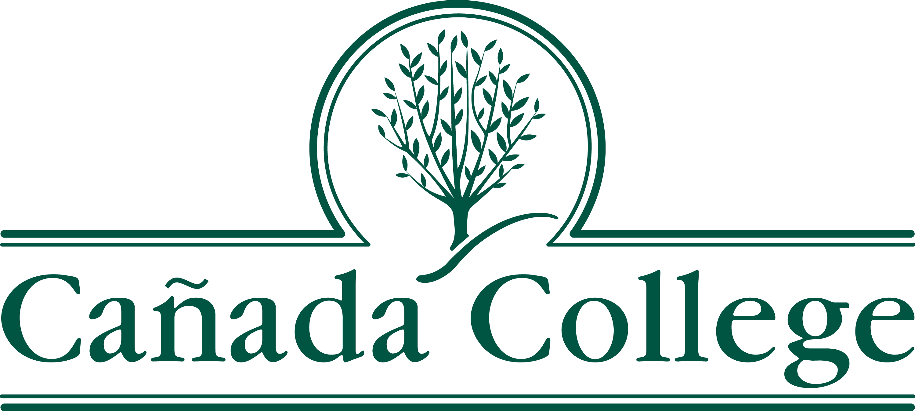

Memo

Date: April 9, 2018

To: Curriculum Committee

From: James Carranza, Interim Dean, Humanities and Social Sciences

Cc: Lezlee Ware, Curriculum Committee representative, HSS
Julie Carey, Curriculum Committee representative, HSS

Subject: Assignment of Disciplines: Life and Culture Courses

HUM. 650 and SOSC 650, Life and Culture, are foundational to the district Study Abroad program in that they are intended to introduce students to the country they are visiting. The curriculum is based on the locale, and so is not particular to either HUM. or SOSC as distinct disciplines. Therefore, the Humanities and Social Sciences division requests that the disciplines listed below, in alignment with general education areas, be assigned as noted to HUM. 650 and SOSC 650.
Title 5 §53407 and §53410 require that faculty who teach credit courses must meet the minimum qualifications as stated in the Disciplines List. Faculty participants in the SMCCCD Study Abroad Program must meet the minimum qualifications for one of the disciplines assigned to HUM. 650 or SOSC 650.
Humanities (HUM. 650):  Art, or  English/Linguistics, or  Literature, or  Music, or  Philosophy, or  Spanish, or  Theater Arts | Social Sciences (SOSC 650):  Anthropology, or  Communication Studies, or  Economics, or  History, or  Political Science, or  Psychology, or  Sociology
Curriculum Committee Approval: 5/11/2018
Academic Senate Approval: 5/24/2018

